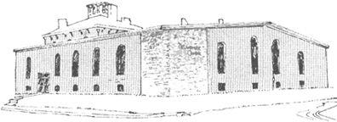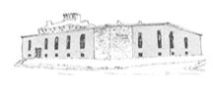

**Deliverance** **Center**

Karsten Peterson

Karsten Peterson

Karsten Peterson

**Center**

Pastor James Reynolds, Sr.

Asst. Pastor Stephen G. Reynolds, Sr.

1008 Congress St. Portland, ME 04102

Tel. (207) 774-8192

[www.**thedeliverancecenter**.com](http://www.thedeliverancecenter.com)

*From the Desk of Pastor Stephen Reynolds, Sr.*

Many warnings have been given at the proper time and place for discipline and devotion for all cell phones to be left on the bureau until permission is given to use them, because people were showing up late for prayer, missing prayer and missing important discipline through devotions.

Notice:

**All Cell Phones must be turned in by 9:00 P.M. Friday 6/10/2011**

If Larry sees a cell phone he is to put out his hand and request that he have the cell phone if this is not granted then it is deeper then just having a cell phone.

Let the Lord help you to pray and He will give you what you need to serve Him.

Sincerely,

Stephen G. Reynolds, Sr.

Assistant Pastor